Lab 4 Mohamamd Danusaputro

What is grayware? [http://computersecurity.wikia.com/wiki/Grayware](https://www.google.com/url?q=http://computersecurity.wikia.com/wiki/Grayware&sa=D&ust=1490245814987000&usg=AFQjCNEnXKOGD6cjkMm_7h_ueFbU-gXuZQ)

Grayware is less series than malware and virus, but still it annoys users. Grayware is general name for software/script/innovation that is less seriously damaging than malware and viruses. That’s why graywares includes but not limited to, spyware, adware, dialers, joke programs, remote access tools. For example they may be installed along with other programs and designed to “learn” your habits and sending them to creator of grayware. These kind grayware is called spyware. Usually your information is used for marketing purposes, but there are some spyware that are designed to steal your login/passwords and take advantage of it. Others keep displaying various advertisements. These are called adware. Spams are also grayware. Spams are sent you automatically by mail sending programs. Your email is retrieved using various ways. When you surf internet you leave your traces/email and other personal info. So some sites collect emails and sell them to other companies. These sites collect your email just offering something foe free download. These are also considered grayware.

2.

Attempt to write JavaScript malware code. Use the built in JavaScript function prompt to ask the user a question. Store the user’s answer in a variable. If the user’s answer does not match your answer repeat until the answer is matched. (Make sure the answer is not the actual answer.) Else break out of the loop. What is different about the prompt if the user does not answer the question correctly the first time? I will give you 20 bonus points if you write code that makes the second prompt look like the first prompt.

Hints:

This is how to ask user for user input/ a question in JavaScript:

var answer = prompt(“what is your name?”);

How to check if the answer is correct:

if(name== “bob”) {break;}

This is one way you repeat statements in JavaScript:

//this will repeat forever unless you tell your browser to stop executing it

while(true){console.log(“hi”);}

**Solution 1**

<!doctype html>

<html lang="en">

<head>

<meta charset="utf-8">

<title>ACTIVITY 2</title>

<meta name="description" content="JavaScript Course">

</head>

<body>

<script>

**var** answer = prompt("Do you want to be rich ?");

**while**(answer!="Of course")

{

**var** answer = prompt("Do you want to be rich ?");

}

</script>

</body>

</html>

**In this solution first question is**

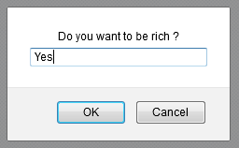

**And second question is**

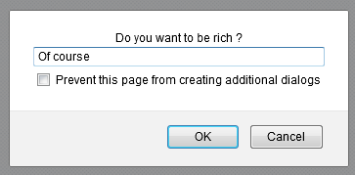

**The question repeats until you enter “Of course”. But in second question browser detects it is grayware and offers to stop it.**

**Solution 2 – Bonus**

<!doctype html>

<html lang="en">

<head>

<meta charset="utf-8">

<title>ACTIVITY 2 Enhanced</title>

<meta name="description" content="JavaScript Course">

<!--[if lt IE 9]>

<script src="https://cdnjs.cloudflare.com/ajax/libs/html5shiv/3.7.3/html5shiv.js"></script>

<![endif]-->

</head>

<body>

<script>

**var** answer = prompt("Do you want to be rich ?");

**if**(answer!="Of course")location.reload();

</script>

</body>

</html>

**In this version if answer is not “Of course” it keeps asking and never offers to stop it. The trick is we reload the page if answer is wrong.**



